|  |  |  |
| --- | --- | --- |
| **Problem Chosen** C | **2024 MCM/ICM Summary Sheet** | **Team Control Number** 2410809 |

summary

【英文字体大小】

【右上角的页码从哪里开始编号】

【正文里答案可以标粗】

【可以用“我们”】

【总分总写法】

【对图的分析要充分】

【摘要第一段写一下背景，3-4行】

每段开头：Firstly Secondly Next Besides Finally

**Keybord:**

**Content**

summary 1

1 Introduction 3

1.1 Background of the Problem 3

1.2 Restatement of the Problem 3

1.3 Literature review（文献综述） 4

1.4 Our Work（问题分析的精简版） 4

2 Assumptions and Notations（假设和符号） 6

2.1 Assumptions（问题假设） 6

2.2 Natations(符号说明) 6

3 Data processing 7

3.1 Processing missing value 7

3.2 Handling of outliersm 8

4 Task 1 Capture game flow 9

4.1 建立势头模型 10

4.2 确定 $xt$ 10

4.3 选择平滑系数 $λ$ 13

4.4 可视化比赛流程 14

5 Task 2 探究势头的作用 15

5.1 探究相减势头的时间序列是否随机 15

5.2 讨论势头与比赛结果的关系 17

5.3 小结 19

6 Task 3 探究比赛流程的转变 19

6.1 预测波动 20

6.2 寻找与波动最相关的因素 22

6.3 提供建议 24

7 Task 4+解决的问题 25

7.1 aaaaaaaaaaaa 25

7.2 aaaaaaaaaaaa 25

8 备忘录 25

9 Sensitivity Analysis（敏感性分析） 25

10 Model Evaluation and Further Discussion 25

10.1 Strength（优点） 25

10.2 Weaknesses（缺点） 25

10.3 Further Discussion（推广） 26

References【单独一页】 27

# 1 Introduction

## 1.1 Background of the Problem

In the 2023 Wimbledon World Cup final, 20-year-old Spanish rising star Carlos Alcascaras defeated 36-year-old Novak Djokovic. Djokovic, one of the greatest players in Grand Slam history, lost for the first time.

Here's a recap of how they played. Djokovic won the first set 6-1, Alcalas won the second set 7-6, and the next set 6-1. But it was Djokovic who won the fourth set 6-3. So far, Alkaras has settled for a draw with Djokovic. In the early stages of the fifth set, Djokovic held a commanding 4-0 lead, but from the fifth game, Alkaras stormed back to take the fifth set 6-4. So the final winner of this game is Alcaras.

As can be seen from the above, there have been many "momentum" shifts in this game. The dictionary definition of momentum is " strength or force gained by motion or by a series of events. "; In sports, it means "strength." Often manifested as a phenomenon that is difficult to measure, a team or player may feel that they have momentum during a game . However, the influence of various events in the game on the "momentum" shift is not obvious.

## 1.2 Restatement of the Problem

Given the context as well as every point data after the first two rounds of the men's competition at Wimbledon 2023, the following questions need to be addressed in this paper:

* Task 1 required building a model that would allow it to identify the better performers at a particular time in the race, as well as reflect how well they performed. And show the flow of the game in a visual way.*Note: Players tend to perform better when serving, so this can be factored into the model.*
* Task 2 asks to evaluate a coach's view, based on a model, that game fluctuations are random and that "momentum" does not play a role in a game.
* Task 3 requires using data from at least one match to develop a model that enables it to predict turning points in a match, that is, which events will affect the direction of the outcome of the match, and analyze which factors are associated with it. And take into account the differences in the "momentum" fluctuations of the game, to provide suggestions for a new game.
* Task 4 requires testing the model to assess the accuracy of the model's predictions and its generalization to other sports or competitions (such as Women’s matches , tournaments, table tennis, etc.).
* Task 5 asked to write a memo, includes a summary of the results, suggestions for coach how to use "momentum", about players affect the process of incident response.

## 1.3 Literature review（文献综述）

## 1.4 Our Work（问题分析的精简版）

* 第二题首先把p1的累计得分，和0-1得分得到，然后我们还有一个M(k=2)/M(k=1)数据，首先对这三个数据进行ADF检验，看是否平稳。然后交叉相关分析（检验两组时间序列线性相关）和Granger因果检验。得出初步结论（相对势头）和（成功得分）有没有关系。然后再用ACF检验和PACF检验来看一下相对势头的时间序列数据是否是随机的，还是具有一定的联系。

【放思维导图+一些解释（背景色要淡，字不能太小）】

* 2317本文接下来的内容安排如下。在第二节中，我们介绍了前提假设和理由，并在第三节中提到了公式中的常见变量。第四部分是建模前的数据预处理。第五节建立报告编号区间预测模型，并探讨词属性与模式选择之间的关系。第六节，建立报告结果分布预测模型。第七节，我们提出了单词难度分类模型。第八节继续探讨数据文件的有趣特征。第九节和第十节分析了模型的灵敏度，并进一步评估了模型的优缺点。最后，第十一节给出结论。
* 2351基于对问题的分析，我们提出了图 1 所示的模型框架，主要由以下几部分组成：

**数据分析**：处理报告数据并确定词语的特征。

**预测模型**：选择 Prophet 算法建立时间序列回归预测模型，并使用高阶偏相关分析找出各属性的影响程度。

**开发多目标回归预测框架**：利用该框架帮助我们选择 Lasso 回归预测模型。

**难度区间划分**：使用 K-means 算法将单词难度分为三类，并通过 Lasso 回归预测对分类结果进行验证。

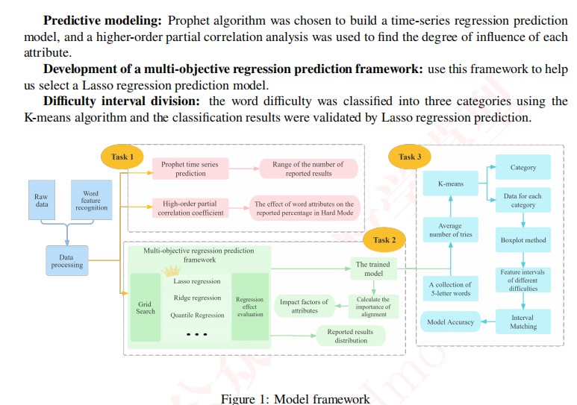

* 2336【可以学习，很模板化】

首先，我们构建了可以衡量词语熟悉程度、构成特征、关联程度和混淆程度的四类指标，并用这些指标来反映词语的属性。【针对问题 1，我们基于 SIR 模型建立了一个名为 "目标-两名玩家-流失（T2PL）"的动态系统，以解释 Wordle 报告的每日波动。此外，玩家还被分为两类：普通玩家和忠诚玩家，每类玩家的流失率各不相同。这样，模型就能更好地模拟不同时间段内不平等的流失率。我们还探讨了单词属性与 "困难模式 "玩家数量之间的关系，发现某些属性会影响 "困难模式 "报告的百分比。】

其次，我们在 SIR 模型的基础上开发了 T2PL 模型，该模型是一个动态模型，可以很好地解释所报告结果的数量和所报告的 "困难模式 "结果所占百分比的总体趋势。在此基础上，我们探讨了单词属性对所报告的 "困难模式 "结果百分比的影响。【针对问题 2，我们开发了一个 P&S 模型，该模型使用模拟算法和梯度下降法来模仿玩家猜词和分享游戏结果的行为。模拟器的工作原理是利用可观察到的信息剔除所有不满意的单词，然后以单词频率为权重从剩余的单词列表中随机抽取单词。然而，我们发现模拟结果与真实分布并不完全一致。因此，我们用 7 个变量重新调整了分布，这 7 个变量代表了玩家在获得不同分数时分享分数的可能性。通过梯度下降法对它们进行优化，可以生成更好的分布预测。使用 P&S 模型，我们预测 EERIE 一词在 2023 年 3 月 1 日的分布为（0, 0, 9%, 29%, 45%, 14%, 3）】

第三，我们利用该算法模拟了wordle玩家猜词时的策略，从而模拟了结果的初始分布。考虑到玩家的心理特点，我们添加了表示玩家分享分数意愿的参数，并模拟了报告结果的最终分布。【对于问题 3，我们需要按难度对谜题进行分类。我们使用 3 个聚类 K-means 对所有报告的试题分布进行聚类分析，每个聚类分为简单、中等和困难。我们使用随机森林模型，利用开头定义的属性指标将谜题分为这三个类别。我们计算了每个指标与难度之间的相关系数，以显示这些指标对谜题难度的影响方向。同时还讨论了聚类的敏感性。根据我们的模型，EERIE 的难度为难】

第四，我们根据得分分布对单词进行聚类，并根据难度将单词分为三类。聚类结果作为标签，用于构建随机森林模型，根据词的属性对词的难度进行分类。【对于问题 4，我们进一步探讨了单词难度的影响。通过线性回归，我们发现单词难度对报告结果的数量有明显的影响：较难的谜题会导致较少的报告。如前所述，难度还与选择 "困难模式 "的人数比例相关。通过这部分研究，我们发现相关性是由单词难度影响普通模式玩家人数而形成的。】

最后，根据上述模型的结果，我们进行了进一步的探索，发现了一些有趣的结论。【通过发现单词属性、谜题难度和游戏报告模式之间的相互作用，Wordle 操作员可以更深入地了解玩家。基于这一发现，我们还可以提出一些合理的建议。】

# 2 Assumptions and Notations（假设和符号）

## 2.1 Assumptions（问题假设）

·**Assumption 1.**-----

Reason 1:----

·**Assumption 2.**-----

Reason 2:---

·**Assumption 3.**-----

Reason 3:---

## 2.2 Natations(符号说明)

Table Nations

|  |  |
| --- | --- |
| Symbol | Definition |
| $$M_{t}^{(k)}$$ | 玩家*k*在 $t$ 时刻下的势头 |
| $$s$$ | 开始换局或休息的时间点 |
| $$y_{1}$$ | serve_no |
| $$y_{2}$$ | server |
| $$y_{3}$$ | winner_shot_type |
| $$y_{4}$$ | pk_double_fault |
| $$y_{5}$$ | pk_unf_err |
| $$y_{6}$$ | pk_net_pt |
| $$y_{7}$$ | pk_break_pt |
| $$y_{8}$$ | p1_distance_run与rally_count的比值 |
| $$y_{9}$$ | speed_mph与100的比值 |
| $$y_{10}$$ | (p1_points_won-p2_points_won)与(p1_points_won+p2_points_won)的比值 |
| $$y_{11}$$ | pk_ace |
|  |  |
| $$p_{1}$$ | p1_points_won |
| $$p_{2}$$ | P2_points_won |

# 3 Data processing

In order to make the data better adapt to the requirements of the model and the characteristics of the algorithm, we usually need to preprocess the data before formally solving the problem.

## 3.1 Processing missing value

There may be missing values in the raw data, and a heat map can help us detect this, visualizing the distribution of missing values.A heatmap of the raw data is presented below.

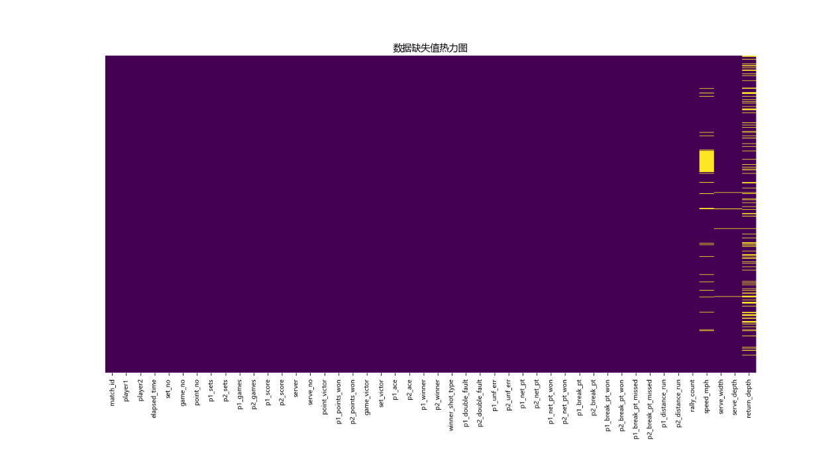

图 Heatmap of missing data

In the graph, purple represents non-missing values and yellow represents missing values. As can be seen from the figure, the data of most indicators are complete, but some indicators obviously have missing values. Further, we can see that a whole block of "speed_mph" is missing, "serve_width, serve_depth" has fewer missing values, and "return_dept" has more dense missing values.

In order to improve the quality of the data and ensure that the model can make better use of the information, we fill in the missing values, as follows:

* **For speed_mph**: After looking at the table data based on the above results, we found a whole block of missing values in lines 2187 to 2674, namely Daniel Elahi Galan vs. Mikael Ymer and Guido Pella vs. Roman Safiullin. Therefore, the average of players with similar rankings can be used instead. For the rest, we will fill forward or backward using numerical time series.
* **For serve_width**: serve_depth: Since the missing values of these two indicators are less, the mode "C" and "NCTL" are used to fill.
* **For return_dept**: The original data only has D and ND, so for missing values, we can introduce "MD" (medium depth) instead.

According to the above method, the data obtained after processing is shown in the following table (only part is shown here) :

表 Data processed with missing values (part)

|  |  |  |  |  |  |  |
| --- | --- | --- | --- | --- | --- | --- |
| match_id | player1 | player2 | **speed_mph** | **serve_width** | **serve_depth** | **return_dept** |
| 2023-wimbledon-1301 | Carlos Alcaraz | Nicolas Jarry | 125 | C | NCTL | MD |
| 2023-wimbledon-1302 | Alexander Zverev | Matteo Berrettini | 106 | C | NCTL | MD |
| … | | | | | | |
| 2023-wimbledon-1310 | Daniel Elahi Galan | Mikael Ymer | 115 | C | NCTL | MD |
| 2023-wimbledon-1311 | Guido Pella | Roman Safiullin | 115 | C | NCTL | MD |
| … | | | | | | |

## 3.2 Handling of outliersm

(1) p1_score and p2_score

There may also be outliers in the raw data. On a preliminary analysis of the raw data, we found that the p1_score and p2_score fields should contain only a few specific values (0,15, 30, 40, AD), and the rest should be treated as outliers.

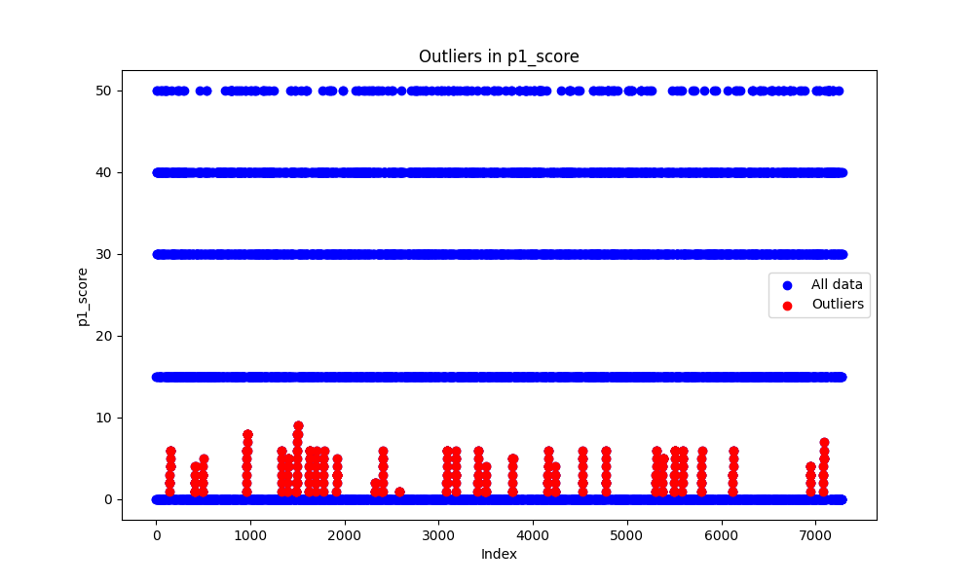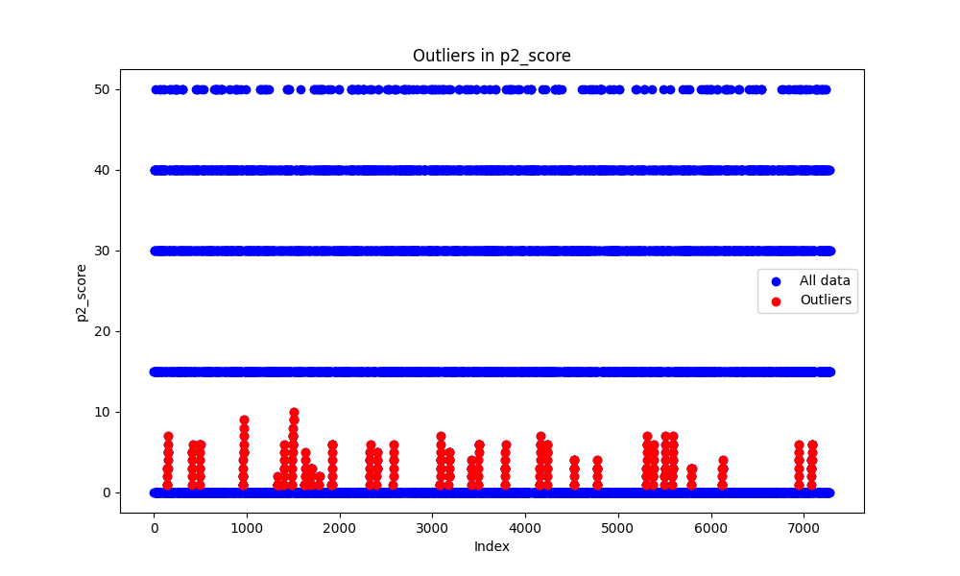 Therefore, we can use rule-based anomaly detection to analyze the data, which is especially suitable for cases where there is a clear set of valid values in the data. At the same time, we define AD as 50, that is, we define specific values as (0,15, 30, 40, 50). Below is the test result.

图 Outlier detection results for p1_score and p2_score

As can be seen from the figure, in all the data, the p1_score and p2_score fields have outliers between 0 and 10.

However, considering that the data of these two features have little significance for the following modeling, we choose to delete all the data of these two features.

(2) p1_points_won和p2_points_won

In fact, the outliers in this part were discovered by accident in the subsequent problem solving process. In order to ensure the consistency of the structure of the paper and avoid the influence of the bad outliers, we choose to give corresponding treatment here.

表 Outliers of the original data

|  |  |  |
| --- | --- | --- |
| Line | p1_points_won | p2_points_won |
| 4055 | 12 | 8 |
| 4056 | 21 | 21 |

It can be seen from the table that the values of 12 and 21 and 8 and 21 in these two rows are not continuous, but mutated. Based on the two metrics "p1_points_won" and "p2_points_won" which mean "the cumulative score of the player", we know that there is an outlier.

Combining the actual meaning of the two indicators, as well as the actual meaning and data of other indicators in the original data, we can easily deduce the correct value. The following shows the results after processing.

表 Processed p1_points_won and p2_points_won

|  |  |  |  |  |  |  |  |  |  |  |
| --- | --- | --- | --- | --- | --- | --- | --- | --- | --- | --- |
| line | p1_points_won | p2_points_won |  | line | p1_points_won | p2_points_won |  | line | p1_points_won | p2_points_won |
| 4035 | 12 | 9 |  | 4043 | 16 | 13 |  | 4051 | 18 | 19 |
| 4036 | 12 | 10 |  | 4044 | 16 | 14 |  | 4052 | 18 | 20 |
| 4037 | 12 | 11 |  | 4045 | 17 | 14 |  | 4053 | 19 | 20 |
| 4038 | 13 | 11 |  | 4046 | 17 | 15 |  | 4054 | 20 | 20 |
| 4039 | 14 | 12 |  | 4047 | 17 | 16 |  | 4055 | 21 | 20 |
| 4040 | 14 | 12 |  | 4048 | 17 | 17 |  | 4056 | 21 | 21 |
| 4041 | 14 | 13 |  | 4049 | 18 | 17 |  |  |  |  |
| 4042 | 15 | 13 |  | 4050 | 18 | 18 |  |  |  |  |

As can be seen from the table, outliers appear in lines 4035-4055. Further, we can see that during this period, player 1 was first ahead of Player 2 by 2 or 3 points, but was gradually evened by Player 2.

# 4 Task 1 Capture game flow

在这一部分，我们首先建立了势头的EWMA模型，用于捕捉得分发生时的比赛流程。然后根据模型分别求出球员1和球员2随比赛流程变化的势头，并根据两者的相减势头来比较它们的表现。

## 4.1 Establishing the Momentum Model

The EWMA (Exponentially Weighted Moving Average) model is a commonly used smoothing method in time series analysis to capture trends and changes in data.

In this problem, to better understand the changes in player performance during the game, we consider momentum as the dependent variable and define the momentum at a certain moment as the "technical performance at that moment" plus the "momentum from the previous moment". Specifically, "technical performance at that moment" is related to indicators such as double faults, service winners, unforced errors, and ace serves.

Based on the analysis above, the Exponentially Weighted Moving Average model we established is as follows: the momentum of player $k$ at time $t$ is

$$M_{t}^{(k)}=λx_{t}+(1-λ)M_{t-1}^{(k)}$$

where $λ$ is the smoothing coefficient, usually ranging from 0 to 1，indicating the weight of $x_{t}$, with larger values indicating greater emphasis. $x_{t}$ is the "technical performance at the moment," calculated from the original scores based on match events.。 $M_{t-1}^{(k)}$ is the momentum of player k at time $t-1$.

Since $x_{t}$ is related to multiple technical indicators, it can be expressed as

$$x_{t}=ω_{1}y_{1}+ω_{2}y_{2}+…+ω_{n}y_{n}$$

Where $y_{1},y_{2},…,y_{n}$ are the technical indicators.

From the analysis above, it is easy to see that the key to determining the momentum $M_{t}^{(k)}$ at time $t$ is to determine $λ$ and $x_{t}$.The details are explained below.

## 4.2 确定 $x_{t}$

4.2.1 技术指标的选取

【微调一下】

在网球比赛中，不同时刻呈现不同的技术表现，这些技术表现在影响比赛势头方面发挥着重要作用。在所提供的比赛数据中，共列出了十多项单打比赛的技术统计指标。为了创建一个平衡的特征集，涵盖技术表现的不同方面，我们给出了下面这12个特征。

$y_{1}$ 为首次发球是否失误。失误记为1，无失误记为0。这个特征捕捉了球员开始比赛时的能力。

$y_{2}$ 为是否作为发球方，因为发球方通常具有战略优势。

$y_{3}$ 为不可触及的镜头类别，这提供了关于球员技能和打法风格的见解。

$y_{4}$ 为双误。双误是重大失误，可能导致失分，监控这一点有助于评估球员的一致性。

$y_{5}$ 为非受迫性失误，表明球员的控制和决策能力。

$y_{6}$ 为成功上网次数，用于展示球员的积极性和结束比赛的能力。

$y_{7}$ 为破发点，说明球员有机会打破对手发球局，这是网球比赛中至关重要的一环。

$y_{8}$ 为跑动距离与射击次数比值，体现了球员在比赛中的移动效率。

$y_{9}$ 为发球速度。

$y_{10}$ 为得分差异比值，它捕捉了球员在赢得比赛中相对于对手的优势，提供了相对度量。

$y_{11}$ 为Ace，展示了球员轻松获得分数的能力。

$y_{12}$ 为短期得分率，是球员当前状态和即时比赛表现的有价值的度量。以下给出具体的数学表达：

规定这个短期是5个回合（考虑了休息时间和换场时间），记为 $η_{t}$

$$η_{t}=\left\{\begin{aligned}\frac{p_{1}}{p_{1}+p_{2}}, t<s+5 \\ \frac{p_{1}}{5}, t=s+5-1 \\ \frac{p_{2}-p_{1}}{5}, 其他情况\end{aligned}\right.$$

其中， $p_{1}$ 表示“p1_points_won”， $p_{2}$ 表示“p2_points_won”， $s$ 表示开始换局或休息的时间点。

对于12个指标进行加权求和，便可得到 $t$ 时刻下根据比赛事件计算的原始得分

$$x_{t}=ω_{1}y_{1}+ω_{2}y_{2}+…+ω_{11}y_{11}$$

其中， $ω_{1},ω_{2},…,ω_{11}$ 分别表示 $y_{1},y_{2},…,y_{11}$ 的权重。但是这些权重暂时也是未知的，因此下面我们来解决这个问题。

4.2.2 Determining the Weights

The Analytic Hierarchy Process (AHP) is a multi-criteria decision analysis method used to determine the relative importance of different factors or criteria.

For the technical performance $x_{t}$, the 12 selected features have varying degrees of importance. Therefore, the Analytic Hierarchy Process is chosen to quantify the importance of these features. The specific steps for applying this method are as follows.

***Step1***:Establishing a Hierarchical Structure of the System

The decision-making problem is decomposed into three levels: the top level is the goal layer M；the middle layer is the criteria layer, which includes five factors: importance C1、commonality C2、immediacy C3、stability C4、and relevance C5 ; the bottom layer is the alternative layer, which consists of the 12 features. The structure is illustrated in the following diagram.

【层次结构图】

***Step2***:Constructing the Judgment Matrix

To compare the features within the decision layer C pairwise, a judgment matrix is constructed as shown below.，

表 Judgment matrix for the 5 criteria in the criteria layer $A_{0}$

|  |  |  |  |  |  |
| --- | --- | --- | --- | --- | --- |
|  | ImportanceC1 | CommonalityC2 | ImmediacyC3 | StabilityC4 | RelevanceC5 |
| ImportanceC1 | 1 | 7 | 5 | 7 | 5 |
| CommonalityC2 | 1/7 | 1 | 1/2 | 1 | 1/2 |
| ImmediacyC3 | 1/5 | 2 | 1 | 2 | 1 |
| StabilityC4 | 1/7 | 1 | 1/2 | 1 | 1/2 |
| RelevanceC5 | 1/5 | 2 | 1 | 2 | 1 |

For each factor, compare the 12 features $y_{1},y_{2},…,y_{11}$ pairwise to obtain 5 judgment matrices $A_{1}\sim A_{5}$。 Below is the judgment matrix $A_{1}$ for the 12 features based on their importance.

表 Judgment Matrix $A_{1}$

|  |  |  |  |  |  |  |  |  |  |  |  |  |
| --- | --- | --- | --- | --- | --- | --- | --- | --- | --- | --- | --- | --- |
| C1 | $$y_{1}$$ | $$y_{2}$$ | $$y_{3}$$ | $$y_{4}$$ | $$y_{5}$$ | $$y_{6}$$ | $$y_{7}$$ | $$y_{8}$$ | $$y_{9}$$ | $$y_{10}$$ | $$y_{11}$$ | $$y_{12}$$ |
| $$y_{1}$$ | 1 | 1/3 | 1/9 | 1/7 | 3 | 1/3 | 1/3 | 2 | 1 | 2 | 1/3 | 2 |
| $$y_{2}$$ | 3 | 1 | 1/3 | 1/7 | 6 | 1/2 | 1/2 | 3 | 2 | 5 | 1/2 | 5 |
| $$y_{3}$$ | 9 | 3 | 1 | 3 | 7 | 5 | 1 | 7 | 3 | 9 | 3 | 9 |
| $$y_{4}$$ | 7 | 7 | 1/3 | 1 | 9 | 1/3 | 1 | 7 | 2 | 9 | 3 | 7 |
| $$y_{5}$$ | 1/3 | 1/6 | 1/7 | 1/9 | 1 | 1/5 | 1/7 | 1 | 1/9 | 3 | 1/9 | 2 |
| $$y_{6}$$ | 3 | 2 | 1/5 | 3 | 5 | 1 | 1/7 | 1 | 2 | 7 | 1/5 | 5 |
| $$y_{7}$$ | 3 | 2 | 1 | 1 | 7 | 7 | 1 | 7 | 2 | 9 | 1 | 7 |
| $$y_{8}$$ | 1/2 | 1/5 | 1/9 | 1/7 | 3 | 1/5 | 1/7 | 1 | 1/3 | 3 | 1/7 | 2 |
| $$y_{9}$$ | 1 | 1/2 | 1/3 | 1/2 | 9 | 1/2 | 1/2 | 3 | 1 | 9 | 1/2 | 2 |
| $$y_{10}$$ | 1/2 | 1/5 | 1/9 | 1/9 | 1/3 | 1/7 | 1/9 | 1/3 | 1/9 | 1 | 1/9 | 2 |
| $$y_{11}$$ | 3 | 2 | 1/3 | 1/3 | 9 | 5 | 1 | 7 | 2 | 9 | 1 | 6 |
| $$y_{12}$$ | 1/2 | 1/5 | 1/9 | 1/7 | 1/2 | 1/5 | 1/7 | 1/2 | 1/6 | 1/2 | 1/6 | 1 |

***Step3***: Consistency Test

Before calculating the weights using the judgment matrices, it is essential to conduct a consistency test for the aforementioned six judgment matrices. Typically, this involves calculating the Consistency Index ($CI$) and the Consistency Ratio ($CR$). A $CR$ less than 0.10 is deemed acceptable, indicating that the consistency of the judgment matrix is satisfactory. The Consistency Index ($CI$) is calculated as $CI=\frac{λ_{max}-N}{N-1}$，where $λ_{max}$ is the largest eigenvalue of the judgment matrix and $N$ is the number of criteria or alternatives. The Consistency Ratio ($CR$) is then determined by $CR=\frac{CI}{RI}$，, where $RI$ stands for the Random Index, which varies based on the matrix's dimension.

Upon calculation, it becomes straightforward to ascertain the results of the consistency tests for the six judgment matrices $A_{0}$ ~ $A_{5}$. The outcomes of the consistency tests for matrices $A_{0}$ through $A_{5}$ are presented in the following

表 Results of the Consistency Tests for Matrices $A_{0}$ to $A_{5}$

|  |  |  |  |  |  |  |
| --- | --- | --- | --- | --- | --- | --- |
|  | $$A_{0}$$ | $$A_{1}$$ | $$A_{2}$$ | $$A_{3}$$ | $$A_{4}$$ | $$A_{5}$$ |
| $$CI$$ | 0.0051 | 0.1420 | 0.0579 | 0.1146 | 0.0668 | 0.0509 |
| $$CR$$ | 0.0046 | 0.0922 | 0.0376 | 0.0744 | 0.0434 | 0.0330 |

Upon examination, it is evident that the Consistency Ratios ($CR$) for matrices $A_{0}$ through $A_{5}$ are all less than 0.20, thereby rendering their consistencies acceptable.

***Step4***:Solving for Weights

Next, we proceed to calculate the weights using the judgment matrices. To ensure the robustness of the results, we employ three different methods: the Arithmetic Mean Method, the Geometric Mean Method, and the Eigenvalue Method, to derive the weights. We then compute the average of these results to determine the final weights. Below, we present the results of calculating weights using judgment matrix $A_{0}$：

表 Results of Weight Calculation Based on $A_{0}$

|  |  |  |  |  |
| --- | --- | --- | --- | --- |
|  | Arithmetic Mean Method | Geometric Mean Method | Eigenvalue Method | Average Value |
| ImportanceC1 | 0.584 | 0.5851 | 0.5864 | 0.5852 |
| CommonalityC2 | 0.0727 | 0.0725 | 0.0723 | 0.0725 |
| ImmediacyC3 | 0.1353 | 0.1350 | 0.1345 | 0.1349 |
| StabilityC4 | 0.0727 | 0.0725 | 0.0723 | 0.0725 |
| RelevanceC5 | 0.1353 | 0.1350 | 0.1345 | 0.1349 |

Based on the table above, we consider the weights of the five factors—importance, commonality, immediacy, stability, and relevance—to be 0.585167, 0.0725, 0.134933, 0.0725, and 0.134933, respectively.

Using the same methodology, we can determine the weights among the 12 features for each factor. The organized data is presented in the following table:

表 Final Weight Table

|  |  |  |  |  |  |  |  |
| --- | --- | --- | --- | --- | --- | --- | --- |
|  | Indicator Weights | $$y_{1}$$ | $$y_{2}$$ | $$y_{3}$$ | $$y_{4}$$ | $$y_{5}$$ | $$y_{6}$$ |
| C1 | 0.5852 | 0.0352 | 0.0705 | 0.2178 | 0.1600 | 0.0192 | 0.0884 |
| C2 | 0.0725 | 0.0943 | 0.1481 | 0.0740 | 0.1588 | 0.0666 | 0.0666 |
| C3 | 0.1349 | 0.0652 | 0.0338 | 0.0328 | 0.0328 | 0.2025 | 0.0675 |
| C4 | 0.0725 | 0.0823 | 0.0456 | 0.0456 | 0.0805 | 0.0923 | 0.1972 |
| C5 | 0.1349 | 0.0619 | 0.0341 | 0.0341 | 0.0355 | 0.1693 | 0.0991 |
| 续表 | | | | | | | |
|  | Indicator Weights | $$y_{7}$$ | $$y_{8}$$ | $$y_{9}$$ | $$y_{10}$$ | $$y_{11}$$ | $$y_{12}$$ |
| C1 | 0.1598 | 0.0239 | 0.0655 | 0.0141 | 0.1307 | 0.0149 | 0.1598 |
| C2 | 0.0666 | 0.0666 | 0.0666 | 0.0666 | 0.0666 | 0.0589 | 0.0666 |
| C3 | 0.2025 | 0.0361 | 0.0422 | 0.0452 | 0.0698 | 0.1696 | 0.2025 |
| C4 | 0.1752 | 0.0472 | 0.0412 | 0.0463 | 0.0897 | 0.0568 | 0.1752 |
| C5 | 0.2063 | 0.0344 | 0.0510 | 0.0353 | 0.0706 | 0.1683 | 0.2063 |

Let the weight of the indicator $Ci$ be $c_{i}$ ($i=1,2,…,5$)；under the category $Ci$,the weight of feature $y_{j}$ is $a_{ij}$.Thus, the weight preceding feature $y_{j}$ can be calculated using the following formula:

$$ω_{j}=\sum_{i=1}^{5}{c_{i}a_{ij}}$$

Considering the actual implications of $y_{1},y_{4}$,and $y_{5}$—which represent first serve faults, double faults, and unforced errors, respectively, and have a negative impact on momentum—it is posited that these three indicators are inversely related to momentum. The final weights obtained are shown in the table below:

表 Final Weights of the 12 Features

|  |  |  |  |  |  |  |  |  |  |  |
| --- | --- | --- | --- | --- | --- | --- | --- | --- | --- | --- |
| Weight | value |  | Weight | value |  | Weight | value |  | Weight | value |
| $$ω_{1}$$ | -0.0506 |  | $$ω_{4}$$ | -0.1202 |  | $$ω_{7}$$ | 0.1662 |  | $$ω_{10}$$ | 0.0273 |
| $$ω_{2}$$ | 0.0645 |  | $$ω_{5}$$ | -0.0729 |  | $$ω_{8}$$ | 0.0318 |  | $$ω_{11}$$ | 0.1067 |
| $$ω_{3}$$ | 0.1452 |  | $$ω_{6}$$ | 0.0933 |  | $$ω_{9}$$ | 0.0587 |  | $$ω_{12}$$ | 0.0627 |

It is evident from the table that the absolute value of $ω_{7}$ is the largest, indicating that $y_{7}$ (break points) has the most significant impact on the original score $x_{t}$； the absolute value of $ω_{10}$ is the smallest, suggesting that $y_{10}$ (the ratio of score difference) has the weakest influence on the original score $x_{t}$.

## 4.3 Selection of the Smoothing Coefficient $λ$

Based on the aforementioned analysis and practical considerations, we believe that at time $t$, if there is a rest period, the impact of $M_{t-1}^{(k)}$ on $M_{t}^{(k)}$ is minimal. Therefore, we preliminarily choose the coefficient before $M_{t-1}^{(k)}$ as 0.35, meaning the model's smoothing coefficient is set to 0.65. The resulting EWMA model for momentum is given by:

$$M_{t}^{(k)}=0.65x_{t}+0.35M_{t-1}^{(k)}$$

Subsequently, using formula (), we calculate the momentum for Player 1 and Player 2, $M_{t}^{1},M_{t}^{2}$。Further, we compare the data obtained with multiple aspects of the match, such as the actual win/loss outcome and player performances, to verify the appropriateness of our chosen coefficients.

Below is a demonstration of the momentum performance for the two players in the match “2023-wimbledon-1301”."

图 Player 1's Momentum

This line graph illustrates the changes in Player 1's momentum throughout the match under a smoothing coefficient of 0.65. After comparing this with the actual match outcomes, player performance metrics, and various other factors, we find that, within this model, the player's momentum aligns most closely with their real-world performance.

图 Player 2's Momentum

This line graph depicts the evolution of Player 2's momentum throughout the match with a smoothing coefficient set at 0.65. After comprehensive comparisons, it is observed that the player's momentum within this model most accurately reflects their actual performance.

Therefore, we select 0.65 as the smoothing coefficient for the final model."

## 4.4 Visualizing the Match Progress

4.4.1 Identifying the Better-Performing Player

To compare the performances of the two players, we introduce the concept of 'Subtracted Momentum':

$$S_{t}=M_{t}^{1}-M_{t}^{2}$$

If $S_{t}$ is greater than 0, then Player 1 performed better; if $S_{t}$ is less than 0, then Player 2 performed better. Below is a display of the 'Subtracted Momentum' for both players in the '2023-wimbledon-1301' match."

图 Subtracted Momentum Between the Two Players

The figure reveals significant fluctuations and frequent changes in the subtracted momentum between the two players, with an even distribution around the zero point. This indicates that the contest for each point within the match was intense, and the overall level of performance between the competitors was closely matched.

4.4.2 球员的具体表现

至于表现更好的球员到底表现有多好，可以用公式()求出该球员在t时刻下的势头，以关注该球员本身的表现。比如，图()和图()可视化了“2023-wimbledon-1301”这场比赛两位球员各自的具体表现。

# 5 Task 2 Exploring the Role of Momentum

In this section, we primarily investigate the linear relationship and causality between momentum and match outcomes. For convenience in our study, we use 'Subtracted Momentum' to represent 'Momentum' and 'Score' to reflect 'Match Outcomes.' Initially, we conducted an ADF (Augmented Dickey-Fuller) test on both variables, followed by cross-correlation analysis and Granger causality tests to explore whether there exists a linear relationship or causality between them. Additionally, we performed an autocorrelation test on 'Subtracted Momentum.

## 5.1 Investigating the Randomness of the Subtracted Momentum Time Series

Before delving into the relationship between 'Subtracted Momentum' and match outcomes, we aim to first focus on the momentum itself, examining whether its time series is random. Prior to conducting an autocorrelation test, it is customary to assess the time series for stationarity.

5.1.1 Stationarity Test

1.Testing the Model

The Augmented Dickey-Fuller Test (ADF test) is one of the most commonly used unit root tests, employed to examine whether a time series possesses a unit root, thereby assessing its stationarity. The specific model is as follows:

The null hypothesis posits the existence of a unit root, indicating the time series is non-stationary; the alternative hypothesis suggests the absence of a unit root, implying the time series is stationary, expressed as:

$$\left\{\begin{aligned}H_{0}：ρ=1 \\ H_{1}：ρ<1\end{aligned}\right.$$

Assuming the time series is represented by:

$$\begin{aligned}∆Y_{t}=ρY_{t-1}+βt+α+ε_{t}\end{aligned}$$

Where $∆$ is the difference operator, $Y_{t-1}$ is the observed value of the time series, $βt$ is the time trend term,， $α$ is the intercept, and $ε_{t}$ is white noise error.

Calculate the p-value of the test statistic; if the p-value is greater than 0.05, then the null hypothesis cannot be rejected, indicating that the time series is non-stationary. If the p-value is less than 0.05, then the null hypothesis is rejected, suggesting that the time series is stationary.

2.Solving the Model

Using software, we obtained the ADF test results at the1%,5%,and 10% significance levels,

表 ADF Test Results for Subtracted Momentum

|  |  |
| --- | --- |
| Subtractive momentum | |
| ADF Statistic | p-value |
| -10.316684188792774 | 3.0841757502686896 $×{10}^{-18}$ |

It is readily apparent from the table that the p-value is significantly less than 0.05, indicating that at the 1%, 5%, and 10% significance levels, we can reject the null hypothesis of the existence of a unit root, thereby considering the data to be stationary.

5.1.2 Testing for Autocorrelation

1.Model Establishment

ACF (Autocorrelation Function) and PACF (Partial Autocorrelation Function) are two commonly used methods for testing autocorrelation in time series analysis, intended to examine the autocorrelation relationships between different lag orders within a time series. Below are the relevant formulas:

1. ACF

For lag order $k$,the autocorrelation coefficient between time series $y_{t}$ and $y_{t-k}$ is calculated as

$$ρ_{k}=\frac{coc\left(y_{t},y_{t-k}\right)}{\sqrt{var\left(y_{t}\right)}\sqrt{var\left(y_{t-k}\right)}}$$

1. PACF

For lag order $k$,the partial autocorrelation coefficient between $y_{k}$ and $y_{t-k}$ is,

$$∅_{kk}=\frac{ cov\left(y_{t},y_{t}-{\hat{y}}_{t-k}\right)}{\sqrt{var\left(y_{t}\right)}\sqrt{var\left(y_{t}-{\hat{y}}_{t-k}\right)}}$$

Where ${\hat{y}}_{t-k}$ is the predicted value obtained by regressing $y_{t-k}$.

2.Solving the Model

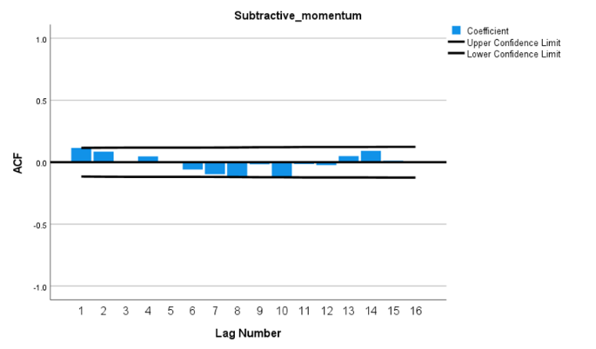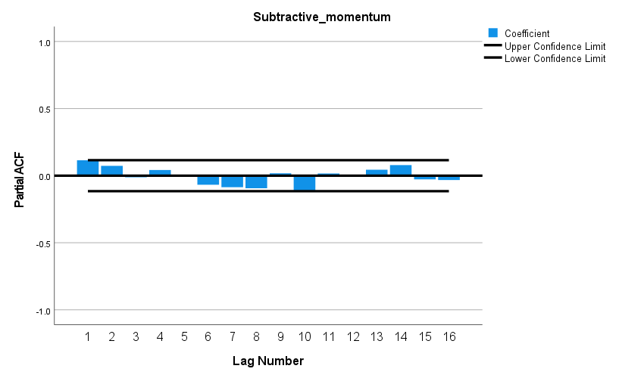

图 ACF and PACF Plots for Residuals

The figure reveals that the autocorrelation coefficients and partial autocorrelation coefficients for all lag orders do not show significant differences from zero, indicating that the residuals constitute a white noise series.

## 5.2 Discussing the Relationship Between Momentum and Match Outcomes

For match outcomes, we consider using 'Cumulative Score' or 'Score' to characterize them, thus transforming the issue into 'discussing the relationship between Subtracted Momentum and Cumulative Score or Score.' Furthermore, we aim to explore both the linear relationship and causality between the two. However, prior to this, it is typically required for the time series of both variables to be stationary, hence the need for stationarity tests.

5.2.1 Stationarity Tests for Cumulative Score and Score Time Series

Having already tested the stationarity of Subtracted Momentum, this section focuses solely on testing the Cumulative Score and Score. The results are presented below.

表 ADF Test Results for Cumulative Score and Score

|  |  |  |  |
| --- | --- | --- | --- |
| Cumulative Score | | Score | |
| ADF Statistic | p-value | ADF Statistic | p-value |
| 0.763834912212 | 0.991029388897 | -14.07951731660 | 2.84517110749 $×{10}^{-26}$ |

From the table, it is easy to discern that the p-value for Cumulative Score significantly exceeds 0.05, indicating that at the 1%, 5%, and 10% significance levels, we cannot reject the null hypothesis of the existence of a unit root, thereby considering the data as non-stationary. However, the p-value for Score is far below 0.05, indicating that at the 1%, 5%, and 10% significance levels, we can reject the null hypothesis, thus the data is stationary.

In summary, both the Subtracted Momentum and the point_victor columns are stationary and can be directly utilized for further modeling work.

5.2.2 Investigating the Linear Relationship Between Subtracted Momentum and Score

1.Model Establishment

Cross-Correlation Analysis is employed to measure the correlation between two time series at different time points. Its principle involves calculating correlation coefficients at various lag times to describe the relationship between the two series. Here are the fundamental principles and mathematical formula for cross-correlation analysis:

For time series $X$ and $Y$ with the same sample length $N$, using $τ$ to represent the lag time, where a positive $τ$ indicates $X$ lags behind $Y$,and and a negative $τ$ indicates $Y$ lags behind $X$.The cross-correlation coefficient at lag time $τ$ is defined as:

$$\begin{aligned}R_{xy}\left(τ\right)=\frac{\sum_{t=1}^{N_{-τ}}{(X_{t}-\overline{X})(Y_{t+τ}-\overline{Y})}}{\sqrt{\sum_{t=1}^{N}{{(X_{t}-\overline{X})}^{2}\sum_{t=1}^{N}{{(Y_{t}-\overline{Y})}^{2}}}}}\#\left(21\right)\end{aligned}$$

Generally, if at a certain lag time, the correlation coefficient is significantly non-zero (i.e., the confidence interval does not include zero), it implies a significant correlation between the two time series at that lag time.

2．Model Solution

By calculating the correlation coefficients at different lag times, we can plot the cross-correlation function graph for Subtracted Momentum and Score.

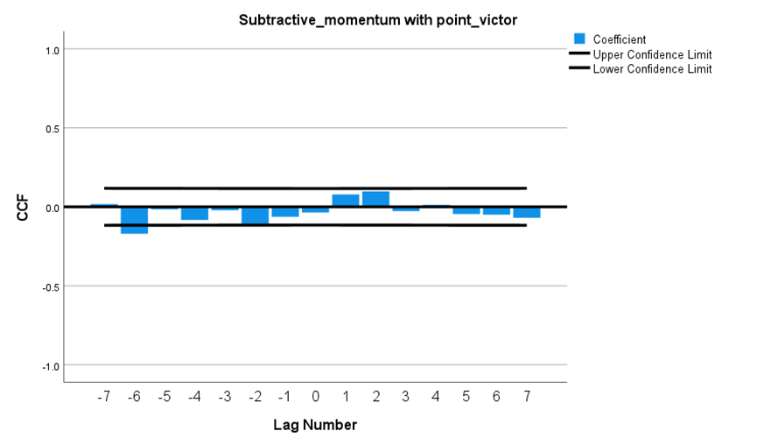

图 Cross-Correlation Function Graph Between Subtracted Momentum and Score

From the graph, we can observe that the confidence intervals for all lag points include zero, indicating no significant linear relationship between Subtracted Momentum and Score within the observed lag range.

Such a result might suggest that the two time series are independent, or their relationship could be non-linear, or the correlation may exist within higher-order dynamic relations.

5.2.3 Testing the Causal Relationship Between Subtracted Momentum and Score

1.Model Establishment

The Granger causality test is a statistical method used to examine the causal relationships between time series data, enabling the investigation of causality between variables. Below is the model for causality testing:

The null hypothesis posits that the time series variable X does not cause changes in the time series variable Y, while the alternative hypothesis suggests that X is the cause of changes in Y, expressed as:

$$\left\{\begin{aligned}&H_{0}：β_{1}=β_{2}=…=β_{q}=0 \\ &H_{1}：β_{i}≠0\end{aligned}\right.$$

The Null Model is:

$$Y_{t}=α+ε_{t}$$

The Alternative Model is:

$$\begin{aligned}Y_{t}=β_{0}+β_{1}Y_{t-1}α+ε_{t}\#\left(22\right)\end{aligned}$$

Parameters for the above models are then estimated using the least squares method, and the test statistic $F$ and the p-valueare derived from the residual sum of squares ${RSS}_{R}$ and ${RSS}_{U}$ of these two regression models:

$$\begin{aligned}F=\frac{{(RSS}_{R}-{RSS}_{U})/q}{\frac{{RSS}_{U}}{n-p-q-1}}\#\left(24\right)\end{aligned}$$

If the test statistic $F$ is significant or the p-value is less than 0.05, the null hypothesis is rejected, indicating the existence of a Granger causal relationship. Otherwise, the null hypothesis cannot be rejected, suggesting no significant causal relationship was found.

2.Model Solution

Upon solving, we obtained the causal test results between Subtracted Momentum and Score，

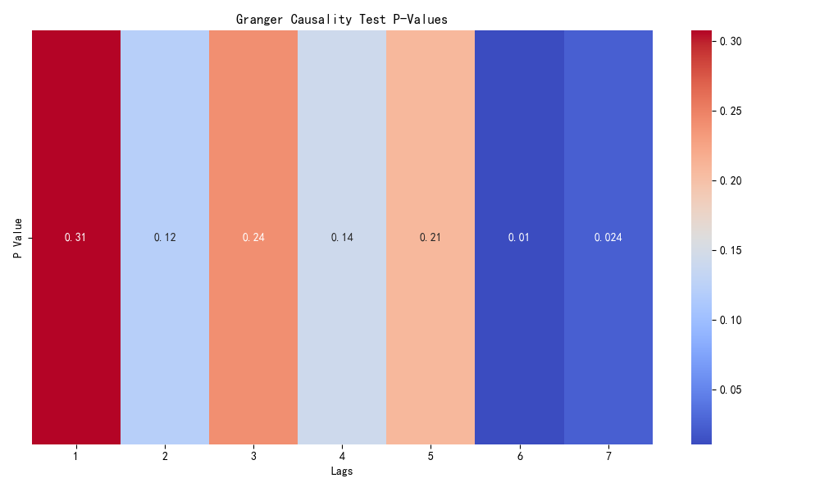

图 Granger Causality Test Results for Subtracted Momentum and Scoring Conditions

The figure indicates that for lags of 6 and beyond, the p-values are less than 0.05, leading to the rejection of the null hypothesis. This suggests that Subtracted Momentum is a Granger cause of the scoring conditions; furthermore, at longer lags, the p-values are very small, signifying even stronger statistical significance.

## 5.3 Summary

The figure reveals that the confidence intervals for all lag points include zero, indicating no significant linear relationship between Subtracted Momentum and Score within the observed lag range.

Such results may imply that the two time series are independent, or the relationship between them could be non-linear, or the correlation may exist within a higher-order dynamic structure.

It is inferred that Subtracted Momentum is a Granger cause of the scoring conditions; notably, at longer lags, the p-values are significantly small, signifying stronger statistical significance.。

# 6 Task 3 Exploring Changes in the Match Progression

In this section, we first established a time series model for predicting fluctuations, followed by conducting stationarity tests, cross-correlation analysis, and Granger causality tests, aimed at identifying the factors most correlated with fluctuations。

## 6.1 Predicting Fluctuations

In the match, we characterize fluctuations using 'Cumulative Subtracted Momentum,' capturing the macroscopic changes of the contest. Due to the temporal interrelation of cumulative subtracted momentum, we opt for a time series model for predictions.

6.1.1 Constructing Time Series Plots

Within our time series model, we have defined time as 'hour:minute,' equating each serve to every minute. This abstraction of the specific serving time, to an extent, facilitates the construction of the time series model. Below is the time series plot for cumulative subtracted momentum.

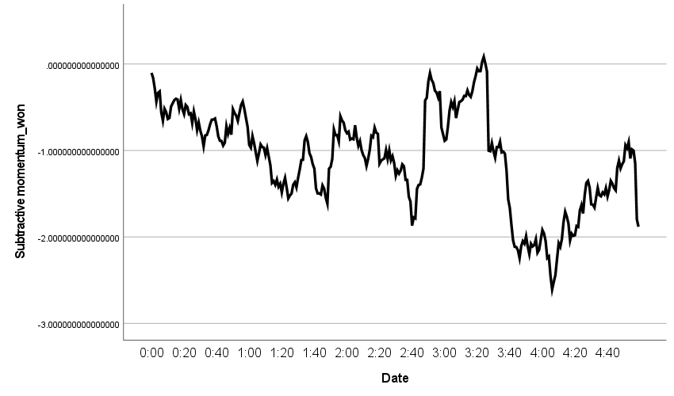

图 Time Series Plot of Cumulative Subtracted Momentum

The figure illustrates that the subtracted momentum exhibits significant overall fluctuations over time, yet during certain intervals, the fluctuations are smaller, suggesting the applicability of an additive decomposition model. Furthermore, it is observed that substantial changes generally occur on the hour, leading to the conjecture that there might be a 60-minute cycle.

6.1.2 Time Series Decomposition

Decomposing the time series reveals a 60-minute cycle. It is also possible to identify the corresponding seasonal factors, which are then plotted on the time series graph to visually examine the seasonal variations.

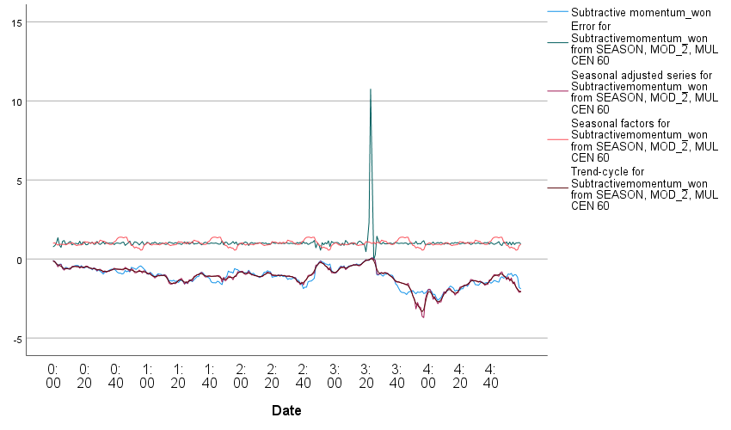

图 Time Series Plot with Seasonal Factors

The figure shows that the orange curve exhibits clear periodic fluctuations, indicating the overall momentum of the match has a certain periodicity. The values corresponding to the green curve are small, suggesting a good fit of the model, but there is a section with a significant spike, which could be due to outliers in the data or a major event not accounted for by the model that influenced the match's dynamics. The red curve fits well with the blue curve, indicating a high goodness of fit for the model.

6.1.3 Model Establishment, Solution, and Testing

Using the SPSS software for expert modeling, the identified model type is Winters' Additive, with the specific formula as follows

$$\left\{\begin{aligned}l_{t}=α\left(x_{t}-s_{t-m}\right)+\left(1-α\right)(l_{t-1}+b_{t-1}) \\ b_{t}=β\left(l_{t}-l_{t-1}\right)+\left(1-β\right)b_{t-1} \\ s_{t}=γ\left({x_{t}-l}_{t-1}-b_{t-1}\right)+(1-γ)s_{t-m} \\ {\hat{x}}_{t+h}=l_{t}+hb_{t}+s_{t+h-m(k+1)}, k=[\frac{h-1}{m}]\end{aligned}\right.$$

Within this model, $t$ represents the current period, $h$ the forecast horizon,and $m$ the cycle length (taken as 60 here), $l_{t}$ the estimated level at time $t$, $α$ as the smoothing parameter for the level, $β$ for the trend, and $γ$ for the seasonality,and ${\hat{x}}_{t+h}$ as the forecasted value for period $h$.

Furthermore, the corresponding coefficients have been obtained: $α=1$， $β=0.001$， $γ=0.001$,These can be substituted into formula () as necessary.

Subsequently, we conducted a test of the model. Since time series models typically assume residuals are white noise, we chose a white noise residual test.。

Specifically, we utilized the Ljung-Box test, a common method for checking whether a series of residuals exhibits autocorrelation.

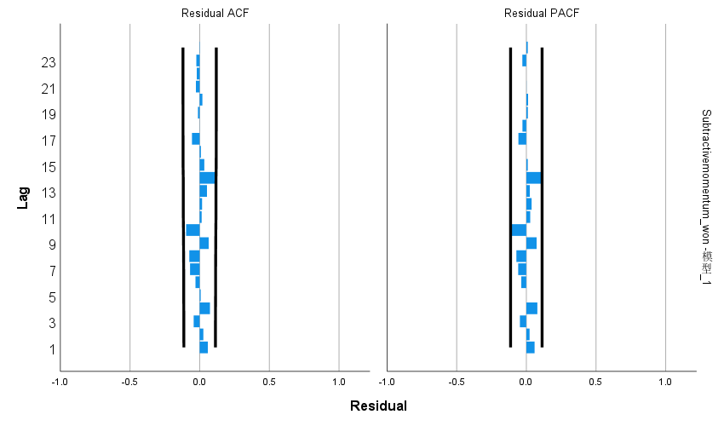

图 White noise residual test

表 Model data

|  |  |  |  |  |  |
| --- | --- | --- | --- | --- | --- |
| Number of Predictors | Stationary R-squared | Statistics | DF | Sig. | Number of Outliers |
| 0 | 0.604 | 17.674 | 15 | 0.280 | 0 |

From the ACF and PACF plots of the residuals, it is observed that the autocorrelation and partial autocorrelation coefficients for all lag orders do not exhibit significant differences from zero; the table reveals a stationary R-squared value of 0.604, a relatively high figure, indicating that the model has well adapted to the stationarized time series. Furthermore, the p-value obtained from the Q test on residuals is 0.280, greater than 0.05, leading us to accept the null hypothesis. Therefore, it is concluded that the residuals are a white noise series, demonstrating that the additive model is capable of effectively identifying cumulative subtracted momentum.

6.1.4 Prediction

Given that the Winters' additive model effectively identifies cumulative subtracted momentum, it can be employed for future predictions.

Since predicting based on information from only one cycle does not yield satisfactory results, we preliminarily choose data from two cycles for the prediction. Below are our predictions for the momentum of the next five matches based on the first two cycles.

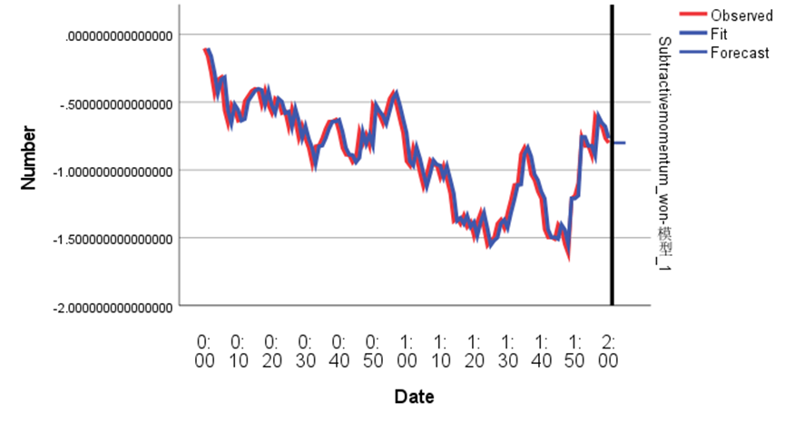

图 Forecast of last five cumulative subtraction momentum based on two cycles

表 Predicted and true values of the last five cumulative subtracted momentums

|  |  |  |
| --- | --- | --- |
|  | 预测值 | 真实值 |
| 1 | -0.79983 | -0.78287 |
| 2 | -0.79983 | -0.87369 |
| 3 | -0.79983 | -0.8627 |
| 4 | -0.79983 | -0.87002 |
| 5 | -0.79983 | -0.70771 |

The graph indicates that the five predicted cumulative subtracted momenta based on two cycles are all -0.79983. This occurrence can be interpreted as indicating that the upcoming match momentum exhibits continuous fluctuations rather than a trend-based momentum. Moreover, the model is particularly accurate when forecasting the most immediate cumulative subtracted momentum. This demonstrates our model's capability not only in predicting the closest cumulative subtracted momentum, i.e., the match momentum, but also in distinguishing whether upcoming fluctuations are periodic or trend-based. In making predictions for other time periods, it also effectively showcases our model's strengths.

## 6.2 寻找与波动最相关的因素

6.2.1 平稳性检验

相关的方法前文已经介绍过了（见公式（）），下面仅展示结果。

表 跳过

表 “累计相减势头”与其他因素的ADF检验结果

|  |  |  |  |  |  |
| --- | --- | --- | --- | --- | --- |
| 指标 | p-value | 指标 | p-value | 指标 | p-value |
| double_fault | 5.441 $×{10}^{-30}$ | y81 | 2.938 $×{10}^{-29}$ | M(t) player2 | 4.261 $×{10}^{-29}$ |
| winner_shot_type | 2.125 $×{10}^{-29}$ | y82 | 4.067 $×{10}^{-9}$ | Subtractive momentum_won  （一阶差分后） | 2.829 $×{10}^{-18}$ |
| Serve | 3.901 $×{10}^{-18}$ | y9 | 1.494 $×{10}^{-19}$ |  | $$×{10}^{-18}$$ |
| serve_no | 3.613 $×{10}^{-25}$ | Y10 | 0.026 |  | $$×{10}^{-18}$$ |
| unf_err | 4.038 $×{10}^{-30}$ | ace | 3.152 $×{10}^{-6}$ |  | $$×{10}^{-18}$$ |
| net_pt | 3.183 $×{10}^{-19}$ | score_rate | 3.072 $×{10}^{-17}$ |  | $$×{10}^{-18}$$ |
| break_pt | 1.145 $×{10}^{-28}$ | M(t) player1 | 2.709 $×{10}^{-28}$ |  | $$×{10}^{-18}$$ |

It is readily apparent from the table that the p-values for all indicators are less than 0.05, indicating that the data is stationary at the 1%, 5%, and 10% significance levels. Hence, it is suitable for use in the next phase of the work.

6.2.2 交叉相关分析

为了探究“累计相减势头”与其他因素的时间序列在不同时间点上的相关性，我们采用交叉相关分析。需要注意的是，这里选择的是一阶差分后的“累计相减势头”时间序列数据，因为它是平稳的。

此分析的方法已经介绍过了（见公式（）），下面具体分析几个具有代表性的结果，其余的仅给出结论。

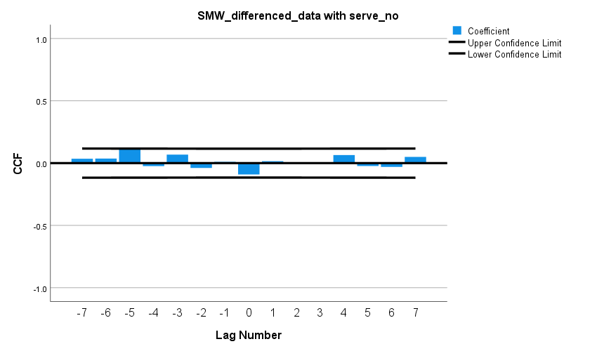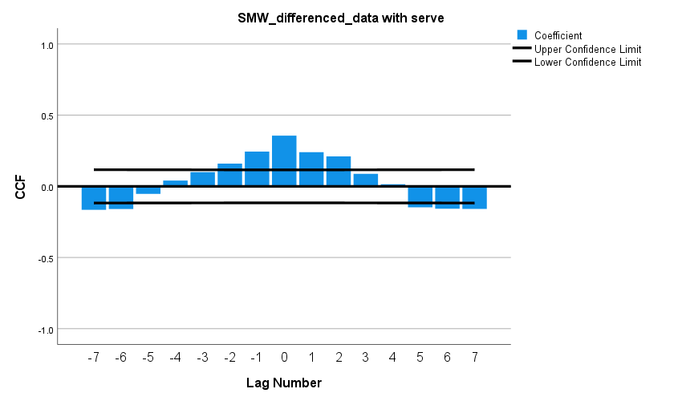1.Individual analysis

图 serve 图 发球失误

The left graph shows that, across most lag periods, there is a relatively clear linear relationship between serve and the cumulative subtracted momentum of the match, exhibiting a periodic distribution. This may be influenced by the cyclical change in the serving player. Some periods do not show a clear linear relationship, possibly due to the effect of alternating serves, which neutralizes the serving advantage. A strong linear relationship at lag 0 could be indicative of a player's consistent serving advantage.

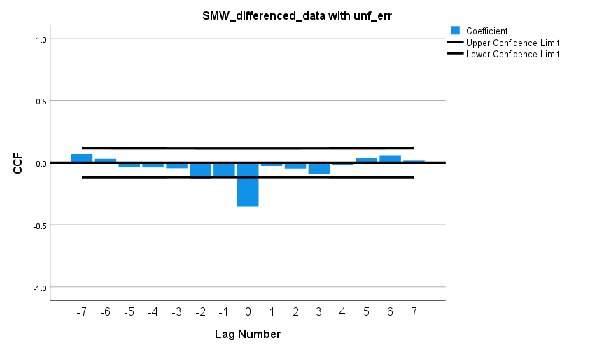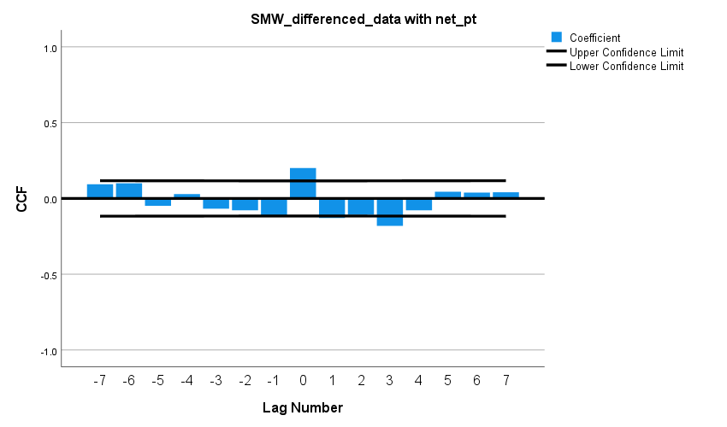 From the right graph, it is evident that service errors do not have a clear linear relationship with changes in cumulative momentum. This might be because the data on service errors were not combined with information on the serving player.

图 Unf_err 图 Net put

The left graph reveals that at a lag of 0, there is a significant negative linear correlation between Unf_err and the cumulative subtracted momentum of the match, which may be influenced by the immediacy and rarity of unforced errors in professional matches.

From the right graph, it is observed that at lags of 0 and 3, there exists a certain linear relationship between Net put and the cumulative subtracted momentum of the match, with one being positively correlated and the other negatively correlated. This could be due to our selection of successful net approaches data without knowing which player made the successful approach.

2.Conclusion

Based on the results, we have categorized the indicators according to the strength of their relationship with the cumulative subtracted momentum:

* With significant linear relationship: Serve, Unf_err, Unf_err (at a lag of 0).
* With weaker or unclear relationship: Double_fault, service errors, Winner_shot_type, Net put, Break_pt, player's physical indicators.
* With no significant linear relationship: y9, y10, ace, scoring rate.

6.2.3 Granger Causality Test

Next, we sought to determine if there is a causal relationship between 'Cumulative Subtracted Momentum' and other factors, thus employing the Granger causality test. The methodology has already been described (see Equation ()), and below are the test results.

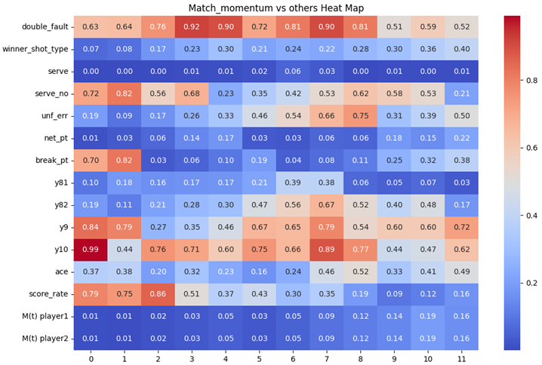

图 “累计相减势头”与其他因素的因果检验

The following information can be gleaned from the graph:

* The p-values for winner-shot-type at lags 1~2 are less than 0.1, which is relatively significant, indicating a certain causal relationship with match fluctuations.
* The p-values for serve at all lags are less than 0.05, very significant, suggesting a clear causal relationship with match fluctuations.
* The p-values for M(t)player1 and M(t)player2 increase with the lag and are less than 0.05 for lags 0~6, significantly indicating a clear causal relationship with match fluctuations.
* The p-values for net-put at lags 01 and 56 are less than 0.05, very significant, indicating a clear causal relationship with match fluctuations.
* The p-values for Y81 (distance run per rally) at lags 8 and 10 are less than 0.1, relatively significant, indicating a certain causal relationship with match fluctuations; at lags 9 and 11, the p-values are less than 0.05, very significant, suggesting a clear causal relationship with match fluctuations.

6.2.4 Summary

Based on the analysis above, overall, Serve, Unf_err, M(t)player1, M(t)player2, and Net_put are the factors most related to match fluctuations, while the relationships of other factors are relatively weak or unclear.

## 6.3 Recommendations

Considering the differences in "momentum" fluctuations in past matches, we propose the following recommendations based on our model research:

* When the cumulative total momentum from the previous match is higher than the opponent's and continues to rise, players should accelerate the pace of the next match to further widen the score gap and consolidate their advantageous position.
* When the momentum from the previous match is even, special attention should be paid to the performance at every point, actively displaying spectacular maneuvers, such as aces. At the same time, it is crucial to avoid unforced errors, like serve faults, to strive for a more advantageous position.
* When the momentum from the previous match is at a disadvantage, it is advisable to slow down the pace of the game while waiting for opportunities to counterattack, aiming to reverse the disadvantage.
* In cases where the momentum from the previous match is advantageous but shows a downward trend, the next match requires vigilance to guard against possible counterattacks.
* When the momentum from the previous match is in a disadvantageous position but shows an upward trend, the next match should be more aggressive in contesting for momentum, making every effort to turn the situation around.

# 7 Task 4+解决的问题

【来一个总起的段落：在这一部分，我们-----】

## 7.1 aaaaaaaaaaaa

## 7.2 aaaaaaaaaaaa

# 8 备忘录

Dear Coach,

To enhance our players' performance against varying game dynamics, I present to you the findings of our research along with some recommendations.

We began by developing an Exponential Weighted Moving Average model for players' momentum, accurately depicting changes during the match. This model precisely reflects short-term momentum shifts and predicts upcoming changes in the game situation. Our validations confirmed the significant impact of momentum on scoring.

For predicting overall game momentum fluctuations, we established a Winsted additive model based on cumulative subtractive momentum, characterized by high fit and reasonable predictive outcomes. We identified serve, Unf_err, and Break_pt as the most relevant indicators to momentum fluctuations. Their impacts are as follows: serve has a strong positive correlation with improving situations, indicating the advantage of serving; Unf_err, or unforced errors, typically signify worsening situations; while Break_pt usually indicates a shift towards a better situation.

Observing these indicators helps us predict momentum shifts, thereby adjusting tactics accordingly. For instance, during service, playing more aggressively is beneficial, whether to expand an advantage or to reverse the game's tide. When the opponent makes unforced errors, seizing the opportunity to build momentum is crucial; conversely, slowing the game's pace to adjust one's state is advisable upon making unforced errors oneself. Aggressively capitalizing on break points can either widen the lead or overturn a disadvantage; caution is advised when facing break points to avoid unfavorable momentum.

Upon testing our model, we found it generally performs well. The results indicate that with sufficient match data, the model accurately predicts short to medium-term game flow changes. However, with limited data within a match, long-term predictions may deviate, though it still performs well in predicting long-term trends. Overall, the model's predictive capability and applicability are commendable and valuable for reference.

Based on our research, I propose the following suggestions, focusing on leveraging momentum to expand the score or counteracting disadvantages to reverse situations:

1.In adverse situations, decelerate the pace, recalibrate your state,。

2.At pivotal momentum shifts, intensify the offense to aim for a turnaround.

3.Under neutral momentum, compete for control, optimizing serving and receiving strategies.

4.When advantageous, amplify the lead while avoiding overconfidence or a false sense of security.

Sincerely,

Team #2410809

# 9 Sensitivity Analysis（敏感性分析）

# 10 Model Evaluation and Further Discussion

模型一：优点利用球员获得杠杆率的指数加权移动平均模型 简单、灵活，特别适合于处理有趋势和季节性的时间序列数据。能很好的定量刻画球员的势头。

缺点：选择合适的平滑指数值有时候比较主观，可能需要通过多次试错或优化方法来确定最佳值。

模型二：优点：对相减势头和point victor 的序列进行了一系列检验如ADF检验 交叉性相关检验 Granger因果检验 自相关性检验等，证明了相减势头和比赛结果有明显的因果关系

缺点：没有找到势头和比赛结果的具体什么关系如线性还是平方还是指数还是几个函数的组合。

模型三：优点：利用历史数据测算出 累计的相减势头序列进行了时间序列模型预测，能很好的描绘整场比赛的流程和比赛总势头，且预测结果在一段时间内的形式较好。通过对累计相减势头与其他指标进行的交叉相关性检验和因果检验能很好的看出哪些具体指标是波动产生的重要指标，及这些指标是怎样影响整场比赛的局势的。对比赛策略的调整具有很好的参考价值。

缺点：该模型无法自动实时更新比赛的历史数据随着比赛时间的推移预测准确度可能会下降，且由于前期比赛开始时历史数据较少模型预测结果可能也不太精确。

## 10.1 Strength（优点）

## 10.2 Weaknesses（缺点）

# References【单独一页】

【期刊名用斜体】

[1]

[2]

[3]

[4]